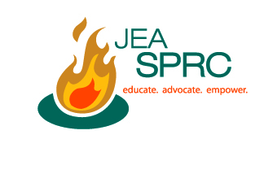

Handling controversy

• 7 ethical dilemmas student journalists face
http://www.hsj.org/Journalism_101/index.cfm?requestAction=goMenuContent&menu_id=7&submenu_id=12&CmsPagesID=223

• Who decides fairness?
http://www.time.com/time/magazine/article/0,9171,908437,00.html

• Endangered species: Censorship threats leave yearbook staffs wondering which way to turn
http://www.splc.org/news/report_detail.asp?id=419&edition=4

• Investigative/backgrounding
http://www.journaliststoolbox.org/archive/investigative/

• Online offers new opportunities, challenges for investigative reporting
http://getsmart.readership.org/2009/04/online-offers-new-opportunities.html

• Reporting on sensitive issues requires sounds policies
http://www.pumarlo.com/recent-writing/reporting-sensitive-issues-requires-sound-policies

• Online defamation law
http://www.eff.org/issues/bloggers/legal/liability/defamation

• ‘Date-rape column’ prompts talk about student publishing controversial content responsibly
http://www.poynter.org/how-tos/newsgathering-storytelling/diversity-at-work/102171/date-rape-column-prompts-talk-about-students-publishing-controversial-content-responsibly/

• FCC: Local TV ‘more important than ever,’ but thin on accountability reporting
http://www.poynter.org/latest-news/top-stories/135318/fcc-report-local-tv-more-important-than-ever-but-thin-on-accountability-reporting/

• How journalism educators can integrate more multimedia into their teaching
http://www.poynter.org/how-tos/journalism-education/113016/how-journalism-educators-can-integrate-more-multimedia-into-their-teaching/

• When reporting goes too far
http://www.rtnda.org/pages/media_items/when-reporting-goes-too-far182.php

•

